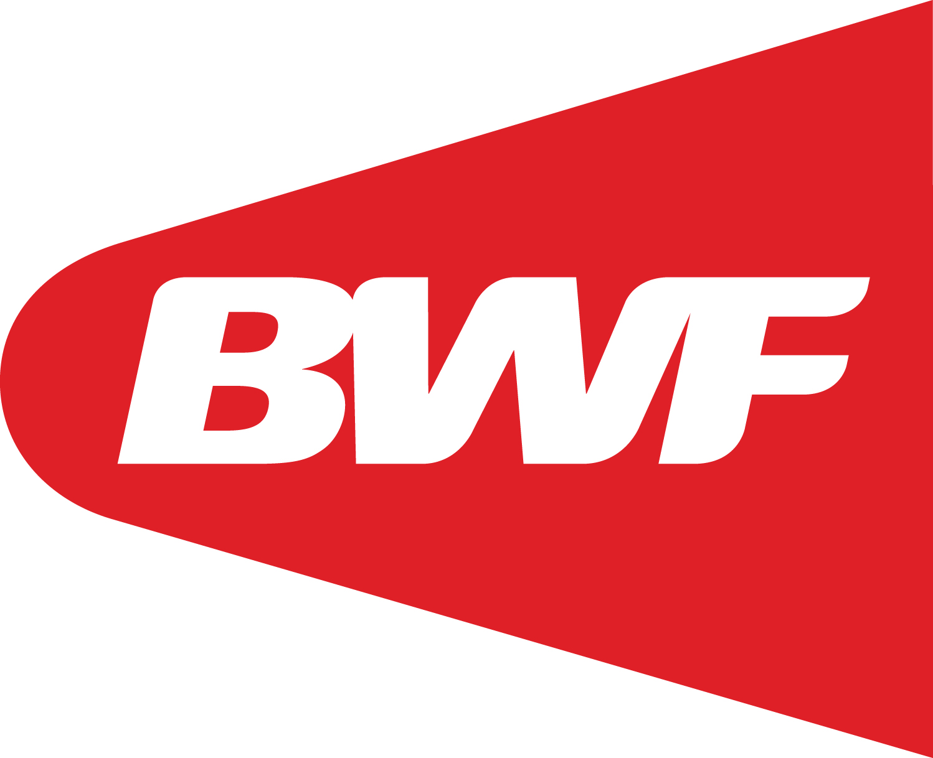 | Appendix 8  Form 2 - Para-Badminton Player Evaluation Consent Form

NAME |  | COUNTRY
COMPETITION |  | DATE  (DD.MM:YYYY)
(Print in CAPITAL LETTERS)

Athlete Declaration and Acknowledgment
I hereby agree to:
- Undergo the classification process as outlined in the BWF Para-Badminton Classification Regulations and administered by the designated BWF Classification Panel.

- Bringing the fully completed Medical Information Form including all the necessary medical information (including x-rays, imaging reports) and records and equipment (prosthesis / sport wheelchair / rackets / playing clothes) to the classification appointment.

- Cooperate at all times to the best of my ability with the instructions and requests made by the Classification Panel, including disclosing details of any medication that I am or will be using prior to or during the course of Player Evaluation to the Classification Panel and to ensure I follow the BWF Players’ Code of Conduct);

- Respect the findings of the Classification Panel. If I do not agree with the results of the Classification Panel I agree to abide by the Protest and Appeals process as defined in the Classification Regulations;

- Be videotaped and photographed during the Player Evaluation process (where such is appropriate, necessary and respects at all times my right to privacy) to include my activity on and off the field of play during the competition. I understand these pictures may be used for educational purposes;

- BWF collating and retaining my personal data in whatever format it may choose, including my full Name, Date of Birth, Competition Class and Competition Class Status, and agree and consent to such data being published by the BWF and/or the International Paralympic Committee.

I hereby acknowledge and understand that:
- Failure to give my best efforts, or misrepresenting my abilities, during Player Evaluation process could result in me being disqualified. I also understand that discrepancies between the performances that I demonstrate during the Player Evaluation process and those that I demonstrate during competition could also result in disqualification.
- The Player Evaluation process will require me to participate in sport-like exercises and activities, and that there is a risk of injury in participating in these exercises and activities. I declare that I am healthy enough to perform these exercises and activities. If I am injured during the course of the Player Evaluation process I will hold BWF and the Classification Panel blameless.
Player’s  Signature |  | Date / Time  (DD.MM:YYYY)
Witness |  | Name of witness (PRINT)

