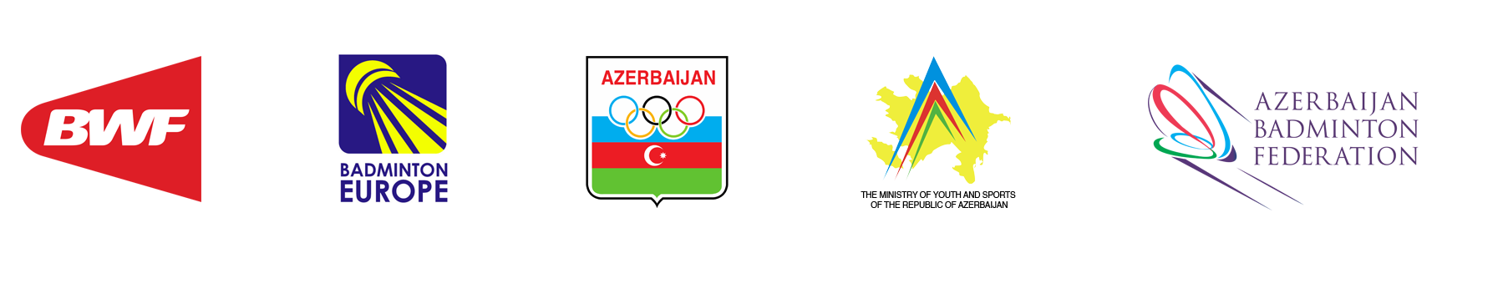
AZERBAIJAN INTERNATIONAL 2020
COURT REQUEST
Submission deadline: 10th July 2020
Please send to: info@badminton.az

Date:
Name of Member Association (Team):
E-mail Address:
Name of Team Representative:
Mobile Phone:

Tournament Hall
Available date: July 15, 2020
Available time: 10:00 – 20:00
Available courts: 4 courts
Location: Baku Sport Hall (Address: Neftchilar avenue 26a, Sabail district)
Reservation: please use Court Request Form for court reservation.

Please fill in your requested practice times.

Date | Requested Time | No. of Players | No. of Courts
July 15, 2020
Tournament Hall

Practice Hall
Available date: July 15-18, 2020
Available time: 10:00 – 20:00
Available courts: 5 courts
Location: Sport Lyceum №1 (Address: 133, Mahsati Ganjavi street, Nizami district)
Reservation: no reservation necessary

