ACCOMMODATION FORM CYPRUS JUNIOR 2021

All reservations must be sent to:
badminton@cytanet.com.cy

CLOSING DATE FOR ACCOMMODATION BOOKING: 30 March 2021

National Association:
Name of Contact Person:
Tel. No:
Fax No:
E-mail:
Preferred Hotel (Choose Asty or Europa Plaza)

Please fill out the accommodation form and send to badminton@cytanet.com.cy In the accommodation form, please choose one of the following 2 official hotels.
The organizer will provide transportation from the official hotels to the venue for persons booking their accommodation through the Cyprus Badminton Federation.

Accommodation closing date: 30th March 2021

Note: All accommodation reservations will be treated on a first-come first-served basis. There is a limited number of rooms available. Payment needs to be settled directly with the hotel.

ASTY Hotel **

12 Prince Charles Str, PO Box 24502, 1300, Nicosia, Cyprus,

 | B/B | Half Board
Single room | 55 | 65
Double room | 85 | 105
Triple room | 110 | 140
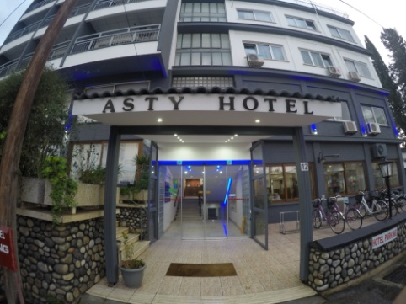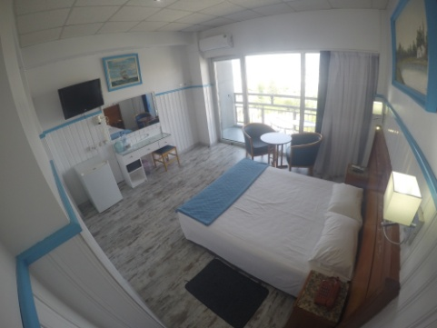
NAME | SURNAME | Room Type  Single, Double or Triple | Terms of Stay (B/B, Half Board or F/B) | Sharing room with | Arrival Date | Depart Date

SEMELI Hotel ***

10 Petraki Yiallourou Street, 1077 Nicosia, Cyprus

 | B/B | Half Board
Single room | 80 | 100
Double room | 110 | 120

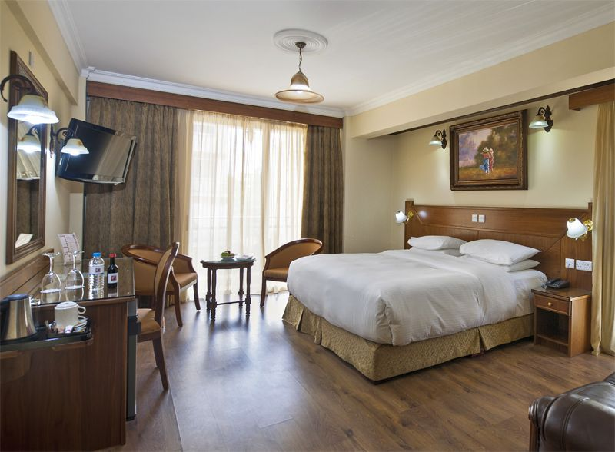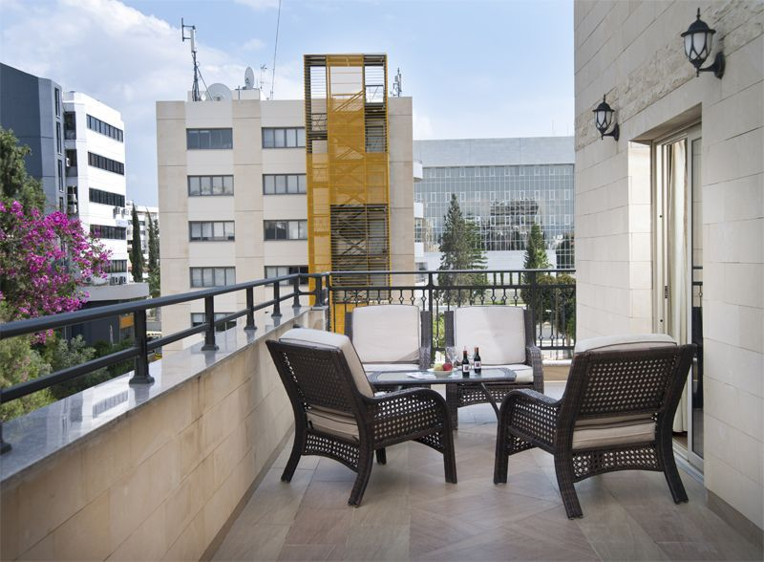

NAME | SURNAME | Room Type  Single, Double or Triple | Terms of Stay (B/B, Half Board or F/B) | Sharing room with | Arrival Date | Depart Date

TRAVEL DETAILS FORM

Please email the travel details form to badminton@cytanet.com.cy
by Tuesday, 30th March 2021

Arrival to Larnaca/Paphos International Airport (please circle arrival airport)
Date: | Time: |  | am/pm
Airline: | Flight No/Origin:
No. of persons:

Names:

Departure from Larnaca/ Paphos International Airport: (please circle departure airport)
Date: |  | Time: | am/pm
Airline: |  | Flight No/Destination:
No. of persons:

Names:

Date: ________________________

Signature:________________________

