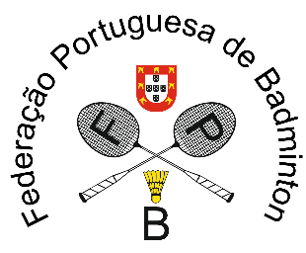
57 Portugal International Championships
Caldas da Rainha, Portugal
March 10 to March 13, 2022

PRACTICE COURT RESERVATION FORM
Wednesday March 9, 2022

Reservations should be made before February 24, 2022

National Association
Contact Person
E-mail address
Phone number

Please note that reservations will be allocated by nation and not by individuals. The number of players which will make use of the practice court(s), will determine the number of practice courts assigned to that nation. The practice courts will be assigned by order of arrival of the reservation.
The practice courts are situated in the venue. Five courts will be available in the mail hall and two in the practice hall.
A confirmed practice schedule will be sent by e-mail on Friday March 4, 2022 and will be available in the main hall.

Requested time | 1st option* | 2nd option* | 3rd option* | Requested number of courts | Number of players
14:00 – 15:00
15:00 – 16:00
16:00 – 17:00
17:00 – 18:00
18:00 – 19:00
19:00 – 20:00
20:00 – 21:00
*Please put an ‘X’ in the preferred row

Please return this form to:
Portuguese Badminton Federation - events@fpbadminton.pt

