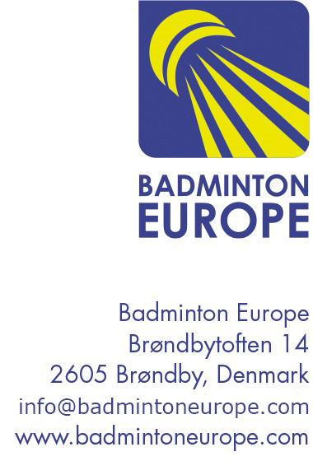
Coach and Tutor Education - application form
Member Association:
Form filled out by:
Position in Federation

Dates of the course:
Type of Course | Coach Education Tutor Education
Level of the course | Level 1 Level 2
City and country course takes place:

Name of tutor or Expert of the course:

Tutor or Expert´s email:

Expected number of participants:

Number of female and male participants

Language used in the course:

Please return this form to Mari Carmen Casermeiro at maricarmen.casermeiro@badmintoneurope.com

