
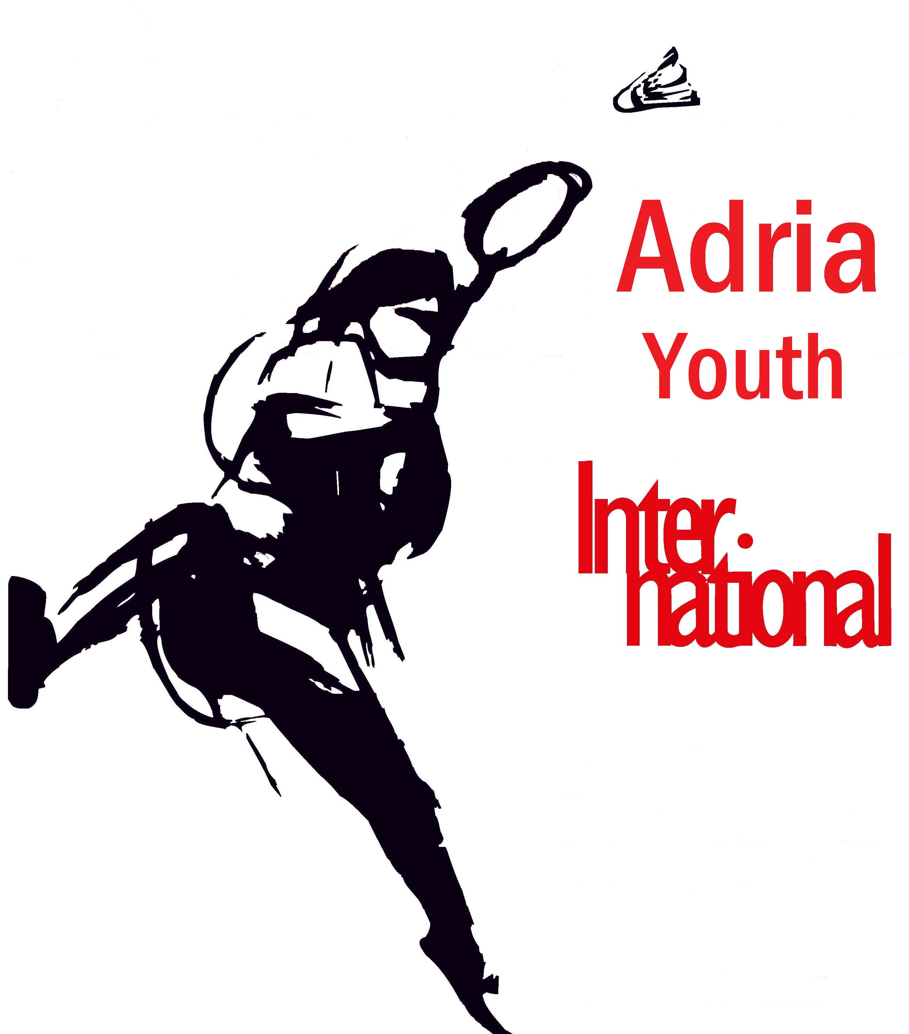
Adria Youth International 2024
CROATIA, Opatija, Adriatic sea
17 - 19 May 2024
U9, U11, U13 and U15 tournaments

closing date: 3 May 2024

______________________________________________________________________________________

ORGANIZER

Badminton klub Stella, 10020 Zagreb, Croatia, Remetinečka 77a &
KŠR Gorovo, 51410 Opatija, Andrije Štangera 48

Tournament Director: Mr Željko Miškulin
Executive Director: Mrs Tatjana Zrnić,
Phone: +385 91 72 71 302 ,
email: info@crointer.com
web: www.crointer.com

VENUE

Sport hall "Marino Cvetković", 51410 Opatija, Stubište Lipovica 3,

Phone/fax: +385 51 680 130, +385 51 401 362

DATE & SCHEDULE

Friday, May 17 - Sunday, May 19, 2024

Friday, 17 May 2024 - 10:00 - 20:00
Saturday, 18 May 2024 - 09:00 - 20:00
Sunday, 19 May 2024 - 09:00 final matches

AGE GROUPS & EVENTS

U9 – born 2016, U11 - born 2014 ; U13 - born 2012 , U15 - born 2010 or younger. All five events.

SYSTEM

Singles: first stage in pools, second stage KO. Doubles: simple KO.

Note First stage: self-officiating KO-stage: loosing players are expected to do the on court officiating.

Organizers reserve the right to change the system due to the volume of entries

ENTRIES

online entries via tournament software link

https://www.tournamentsoftware.com/tournament/5CB2BA2F-7762-4E66-BBC7-57C64309DE6C
or

Badminton club Stella, ENTRY FORM document sent to:
E-mail; info@crointer.com;

Maximum number of entries per single events - 64
Maximum number of entries per double events - 32
First come regulation

ENTRY FEES

25,00 EUR per player per event – singles

20,00 EUR per player per event – doubles

CLOSING DATE

3 May 2024

DRAW

Seeding and draw will be carried out by the CBA.

REFEREE

Tea Grofelnik; E-mail: info@crointer.com Mobile phone: +385 95 80 21 455

SHUTLLES

Victor Tournament Pro Court (15 EUR/tube) and Victor Champion (30,00 EUR/tube) shuttles will be available in the sport hall (should be provided by competitors themselves).

PRIZES

Cups & medals for the first three in each event

MEDICAL SERVICE

Physician and doctor in the sport hall

ACCOMMODATION

Smart Selection Hotel Istra *** 51410 Opatija, Ulica Maršala Tita 143 (new 2019 – swimming pool, transportation between the official tournament hotel and sport hall – 30,00 EUR/per person/all days)

74,00 EUR - day / per person / breakfast in triple room
78,00 EUR - day / per person / breakfast in double room
85,00 EUR - day / with breakfast in single room

Hostel Link, 51215 Lovran, Šetalište Maršala Tita 9 (distance 8 km, transportation between the official tournament hotel and sport hall – 30,00 EUR/per person/all days),

40,00 EUR - day /per person/ with breakfast in double or triple room
60,00 EUR - day /with breakfast in single room

Deadline for ordering accommodation is 1 May 2024.

Smart Selection Hotel Istra *** Hostel Link

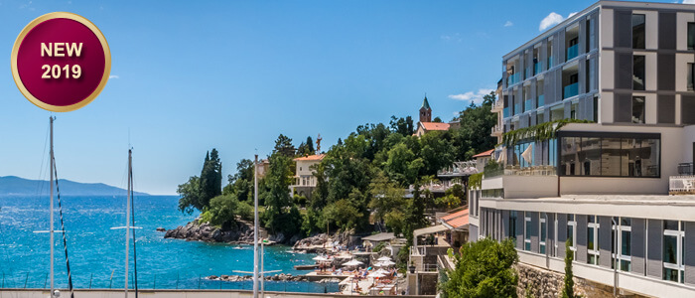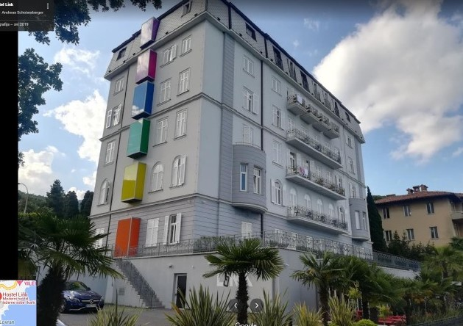

LOCAL TRANSPORT

Transport will be provided from Airport Island Krk to those using the tournament Hotels on receipt of arrival and departure information. Available from 16 – 19 May 2024.

Price and information on demand:
180,00 EUR by automobile (max 4 persons)
280,00 EUR by van (max 8 persons)

Transport from Airport Zagreb (170 km) and returning back, will be organized by BK Stella.

Price and information on demand.
380,00 EUR by automobile (max 4 persons)
550,00 EUR by van (max 8 persons)

- Contact person: Tatjana Zrnić, mobile: +385 91 72 71 302; e mail: info@crointer.com
- Deadline for ordering local transport is 1 May 2024

PLAYERS PARTY

During the tournament at the Hostel Link - lobby - (Saturday at 22,00), will be a big party “Welcome Badminton friends”. The program will be led by DJs, special lighting effects and entertainment. Free entrance and snacks for all participants of the tournament.

INSURANCE

The organizer declines responsibility and covering of costs for possible injuries or other damages. It is up to each participant to insure himself.

NOTE ! ! ! Also the Adria U 17 International 2024 – BEC U 17.

INFORMATION

Contact person: Tatjana Zrnić
Mobile phone: +385 91 72 71 302
Phone: +385 1 66 79 789

E-mail: info@crointer.com
Web: www.crointer.com

SPORT, SEA, SUN is the TOP FUN

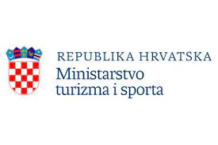
KŠR GOROVO

