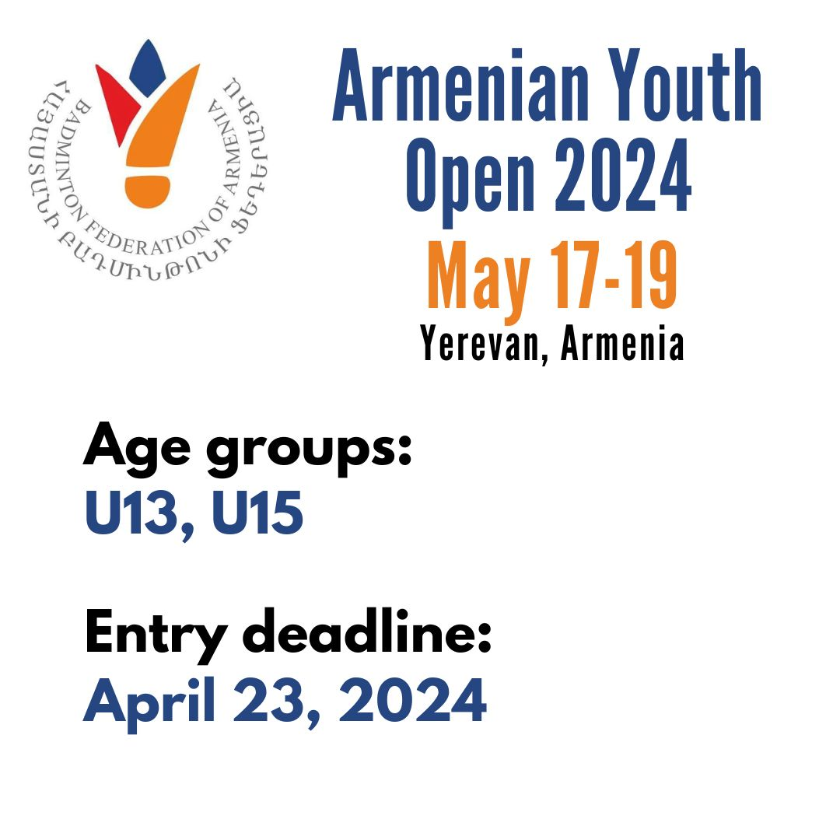

ORGANIZER | Badminton Federation of Armenia, in cooperation and with the support of the Department of Sport and Youth Affairs of Yerevan Municipality  Contact person from the Federation:  Lilit Poghosyan  Email: armbadfeder@yahoo.com  Tel.: +374 91 258881
VENUE ADDRESS | “Tennis and Badminton Sports School”  Address: 12 Ayas street, Yerevan, Armenia  Location:  https://maps.app.goo.gl/ffdBriCsvEcJG7S89
REFEREE | Conor Flatley (Ireland)  refereeconorflatley@gmail.com
DATES | May 17-19, 2024 (Friday – Sunday)
ENTRY FORM | Entry deadline: April 23, 2024  Entries must be sent to armbadfeder@yahoo.com using the tournament entry form. All entries should be sent by order of strength.  No late entries will be accepted.  All entries must be confirmed by their National Associations.
EVENTS AND MAXIMUM NUMBER OF PLAYERS PER EVENT | U15 age group – BS (32), GS (32), BD (16), GD (16), XD (32)  U13 age group – BS (32), GS (32), BD (16), GD (16), XD (16)  A player can participate in a maximum of 3 events: one singles, one doubles and one mixed doubles (if the player enters for singles in U13 age group, they cannot enter for singles in U15 age group)
AGE LIMITS | U15 – born 2010 or later, U13 – born 2012 or later
SEEDING | Seeding will be done by the Badminton Federation of Armenia
DRAW | The draw will be done by the Badminton Federation of Armenia on April 30, 2024.
PRIZES FOR WINNERS | Medals and gifts will be awarded to the winners
ENTRY FEES | Singles: 30 Euros per player  Doubles: 20 Euros per player, per event  The entry fees need to be paid by cash at the tournament before a player’s first scheduled match. The entry fees will not be refunded in the case of a withdrawal.  The Member Association that enters a player into a tournament is responsible for paying the entry fees for that player. The entry fees become due if a player is entered and has not been withdrawn when the entry deadline has passed.
SHUTTLES | Shuttles will be provided for free during the tournament (the brand to be confirmed)
COURTS | 6 rubber courts
CONDITIONS OF PLAY | The tournament will be played in full accordance with the BWF Competition Regulations. Competitors must be prepared to play at the times determined for the events for which they have entered. Competitors will be scratched if not ready to play when called.
SYSTEM | Round robin qualification in groups of 3 or 4 in Singles Events. The 1st and 2nd places in each group will advance to the knock out stage.  Knock out for all Doubles Events.
PROVISIONAL SCHEDULE | Team managers’ meeting:  May 16 (THU) – 20:00 PM (place to be confirmed)  Schedule of the matches:  May 17 (FRI) – 09:00-20:00  Group matches in singles and 1/32 in Mixed Doubles  May 18 (SAT) – 09:00-20:00  1/16 and quarterfinals in all events  May 19 (SUN) – 09:00  Semifinals and Finals, followed by Victory Ceremony  The schedule is subject to change depending on the final number of entries
INSURANCE | Insurance should be arranged individually by each player
MEDICAL SERVICE | Medical staff will be present in the sports hall for the duration of the tournament
ARRIVAL POINT AND TRANSPORTATION | The official Arrival Point is:  Yerevan Zvartnots International Airport  The organizer will provide transportation from the airport to the official hotels and back, and from the official hotels to the venue for the duration of the tournament.  Please fill in the Transportation Form and send it to armbadfeder@yahoo.com by April 30, 2024
VISA | Most European countries do not need a visa to enter Armenia.  Please check below if you need a visa to enter Armenia:  https://www.mfa.am/en/visa/  The Badminton Federation of Armenia will provide full visa assistance upon request. Please send your visa request to armbadfeder@yahoo.com
ACCOMMODATION AND FOOD | Accommodation and food will be provided for free for all the players and coaches for the following days:  - May 16 (Arrival day, check in from 12:00 pm)  - May 17  - May 18  - May 19 (Departure day, check out at 11:00 am)  The organizers will provide rooms in either of the two hotels:  OLYMPAVAN  https://www.multigroup.am/en/company/olympavan.html  https://maps.app.goo.gl/XFK6vBjFzQtwYgxu5  HOTEL OF THE YEREVAN SPORTS COLLEGE OF OLYMPIC RESERVE  https://maps.app.goo.gl/bosvz19acUmig3448  Please fill out the accommodation form and send to armbadfeder@yahoo.com by April 30, 2024.
TRAINING CAMP | There is a possibility to organize a joint training camp together with the Armenian team on the same week of the tournament or after. Please contact Lilit Poghosyan for more details:  armbadfeder@yahoo.com
INFORMATION ABOUT YOUR STAY | There is a grocery shop called “EMmarket” right next to the venue.  “Dalma Garden Mall” is located 7 minutes away by walk from the venue – there is a big supermarket called “Green Line by Yerevan City” in the Mall.  The city centre is only 10 minutes away from the venue. It costs around 5 Euros to get to the city center from the venue by taxi.  Taxi apps used in Armenia:  - GG taxi  - Yandex taxi  Yerevan is quite a small, cozy city and very convenient for tourists. You can walk around the city center and see all the sights in less than 3 hours.  The weather in Yerevan in May is mildly cool, with average highs of 20°C and lows of 7°C.  The official currency in Armenia is the Armenian Dram (AMD).

